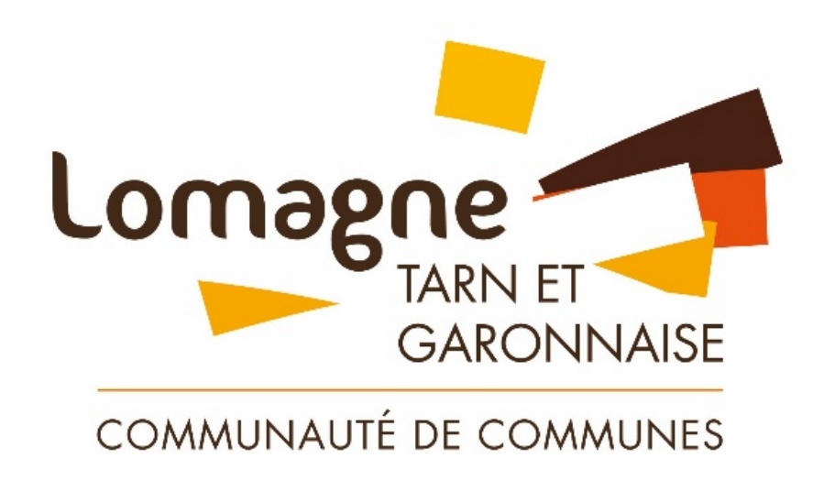

APPEL À CANDIDATURES

ATELIER/LOCAL (2) - 174 M²

ZAE BORDEVIEILLE - BEAUMONT (82)

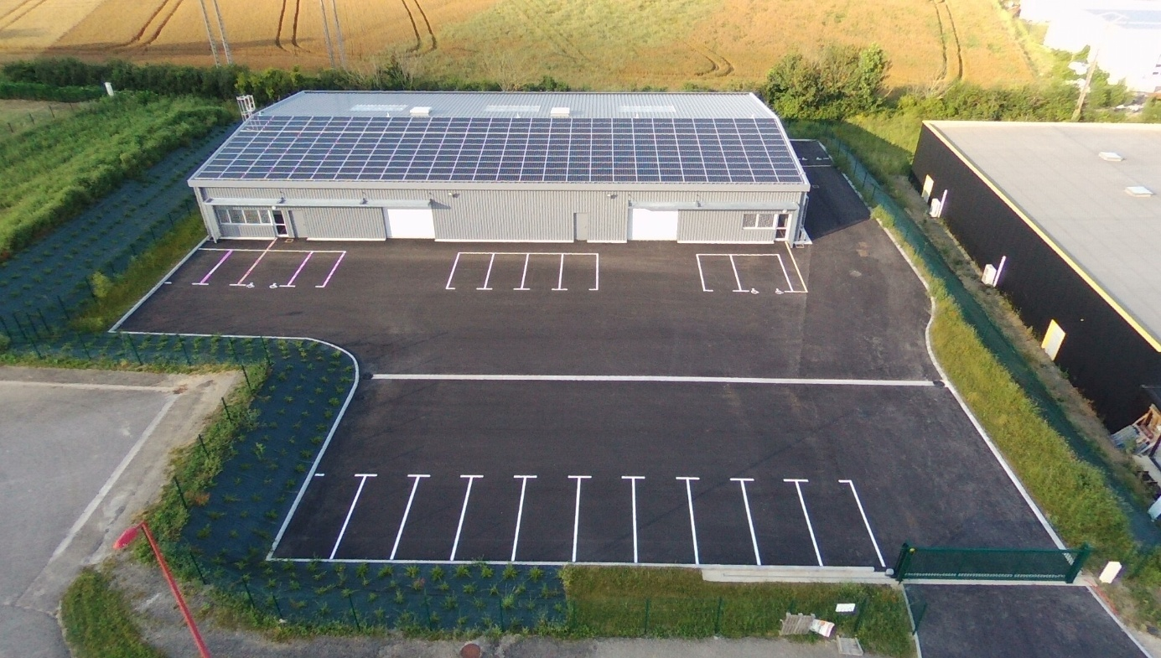

Ouverture de l’appel à manifestation d’intérêt : 09/09/2025  
Date limite de dépôt des candidatures : 06/10/2025

Le dossier de candidature complété et accompagné des pièces annexes est à transmettre au format PDF conjointement aux adresses suivantes : [a.delfau@cc-lomagne82.fr](mailto:a.delfau@cc-lomagne82.fr) & [contact@cc-lomagne82.fr](mailto:contact@cc-lomagne82.fr)

**DOSSIER DE CANDIDATURE**

**PRÉSENTATION DU PORTEUR DE PROJET RÉFÈRENT**

Prénom Nom : ………………………………………………………………………………………………………………………..

Date de naissance : ………………………………………………………………………………………….……………………..

Situation familiale : …………………………………………………………………………………………………………………

Nombre d’enfants à charge : …………………………………………………………………………………………………..

Adresse : …………………………………………………………………………………………………………………………………

Code Postal : …………………… Ville : …………………………………………………………………………………………..

Téléphone : …………………………………………………………………………………………………………………………….

Email : …………………………………………………………………………………………………………………………………….

Un(e) associé(e) ou votre conjoint(e) jouera-t-il un rôle dans l’entreprise ? ………………………………………………………………………………………………………………………………………………………………………………………………………………………………………………………………………………………………

**PARCOURS PROFESSIONNEL PRÉALABLE & FORMATIONS**

Niveau de formation initiale : ………………………………………………………………………………………………….

Précisez vos diplômes et années d’obtention : ………………………………………………………………………………………….…………………………………………………………………………………………………………………………………………………………………………………………………………………………………………………………………………………………………………………………………………………….………………………………………………………………………………………….…………………………………………………………………………………………………………………………………………………………………………………………………………………………………………………………………………………………………………………………………………………….

Situation actuelle (en activité, demandeur d’emploi, salarié, autres) : .……………………………………………………………………………………………………………………………………………….

Parcours métier dont dernier emploi et poste occupé : ………………………………………………………………………………………………………………………………………………………………………………………………………………………………………………………………………………………………………………………………………………………………………………………………………………………………………………………………………………………………………………………………………………………………………………………………………………………………………………………………………………………………………………………………………………………………………………………………………………………………………………………………………………………………………………………………………………………………………………………………………………………………………………………………………………………………………………………………………………………………………………………………………………………………………………………………………………………………………………………………………………

Merci d’indiquer l’état d’avancement des démarches de construction de votre projet :

|  |  |  |  |  |
| --- | --- | --- | --- | --- |
| Actions | Non | Oui, pas démarré | Oui, démarré | Oui, terminé |
| Étude de marché |  |  |  |  |
| Définition Offre/Services |  |  |  |  |
| Étude juridique, fiscale et sociale |  |  |  |  |
| Étude organisationnelle/financière |  |  |  |  |
| Rédaction business plan |  |  |  |  |
| Démarche auprès de banques |  |  |  |  |
| Formation en lien avec la (nouvelle) activité |  | | | |

**NOTICE DESCRIPTIVE DE L’ACTIVITÉ PROJETÉ À L’HÔTEL D’ENTREPRISES  
(EXISTANTE OU CRÉATION)**

………………………………………………………………………………………………………………………………………………………………………………………………………………………………………………………………………………………………………………………………………………………………………………………………………………………………………………………………………………………………………………………………………………………………………………………………………………………………………………………………………………………………………………………………………………………………………………………………………………………………………………………………………………………………………………………………………………………………………………………………………………………………………………………………………………………………………………………………………………………………………………………………………………………………………………………………………………………………………………………………………………………………………………………………………………………………………………………………………………………………………………………………………………………………………………………………………………………………………………………………………………………………………………………………………………………………………………………………………………………………………………………………………………………………………………………………………………………………………………………………………………………………………………………………………………………………………………………………………………………………………………………………………………………………………………………………………………………………………………………………………………………………………………………………………………………………………………………………………………………………………………………………………………………………………………………………………………………………………………………………………………………………………………………………………………………………………………………………………………………………………………………………………………………………………………………………………………………………………………………………………………………………………………………………………………………………………………………………………………………………………………………………………………………………………………………………………………………………………………………………………………………………………………………………………………………………………………………………………………………………………………………………………………………………………………………………………………………………………………………………………………………………………………………………………………………………………………………………………………………………………………………………………………………………………………………………………………………………………………………………………………………………………………

**PROJETS DE DÉVELOPPEMENT DE L’ACTIVITÉ À COURT, MOYEN ET LONG TERME** ………………………………………………………………………………………………………………………………………………………………………………………………………………………………………………………………………………………………………………………………………………………………………………………………………………………………………………………………………………………………………………………………………………………………………………………………………………………………………………………………………………………………………………………………………………………………………………………………………………………………………………………………………………………………………………………………………………………………………………………………………………………………………………………………………………………………………………………………………………………………………………………………………………………………………………………………………………………………………………………………………………………………………………………………………………………………………………………………………………………………………………………………………………………………………………………………………………………………………………………………………………………………………………………………………………………………………………………………………………………………………………………………………………………………………………………………………………………………………………………………………………………………………………………………………………………………………………………………………………………………………………………………………………………………………………………………………………………………………………………………………………………………………………………………………………………………………………………………………………………………………………………………………………………………………………………………………………………………………………………………………………………………………………………………………………………………………………………………………………………………………………………………………………………………………………………………………………………………………………………………………………………………………………………………………………………………………………………………………………………………………………………………………………………………………………………………………………………………………………………………………………………………………………………………………………………………………………………………………………………………………………………………………………………………………………………………………………………………………………………………………………………………………………………………………………………………………………………………………………………………………………………………………………………………………………………………………………………………………………………………………………………………………………………………………………………………………………………………………………………………………………………………………………………………………………………………………………………………………………………………………………………………………………………………………………………………………………………………………………………………………………………………………………………………………………………………………………………………………………………………………………………………………………………………………………………………………………………………………………………………………………………………………………………………………………………………………………………………………………………………………………………………………………………………………………………………………………………………………………………………………………………………………………………………………………………………………………………………………………………………………………………………………………………………………………………………………………………………………………………………………………………………………………………………………………………………………………………………………………………………………………………………………………………………………………………………………………………………………………………………………………………………………………………………………………………………………………………………………………………………………………………………………………………………………………………………………………………………………………………………………………………………………………………………………………………………………………………………

**PRÉVISIONNEL DE L’ACTIVITÉ (CA, RÉSULTAT, ÉVOLUTIONS, ETC.)**

……………………………………………………………………………………………………………………………………………………………………………………………………………………………………………………………………………………………………………………………………………………………………………………………………………………………………………………………………………………………………………………………………………………………………………………………………………………………………………………………………………………………………………………………………………………………………………………………………………………………………………………………………………………………………………………………………………………………………………………………………………………………………………………………………………………………………………………………………………………………………………………………….

**PERSPECTIVES D’EMPLOI**

………………………………………………………………………………………………………………………………………………………………………………………………………………………………………………………………………………………………………………………………………………………………………………………………………………………………………………………………………………………………………………………………………………………………………………………………………………………………………………………………………………………………………………………………………………

**PRODUITS ET/OU PRESTATIONS PROPOSÉS / POSITIONNEMENT …**……………………………………………………………………………………………………………………………………………………………………………………………………………………………………………………………………………………………………………………………………………………………………………………………………………………………………………

………………………………………………………………………………………………………………………………………………

**CLIENTS** ………………………………………………………………………………………………………………………………………………………………………………………………………………………………………………………………………………………………………………………………………………………………………………………………………………………………………………………………………………………………………………………………………………………………………………………………………………………………………………………………………………………………………………………………………………………………………………………………………………………………………………………………………………………………………………………………………………………………………………………………………………………………………………………………………………………………………………………………………………………………………………………………………………………………………………………………………………………………………………………………………………

**FOURNISSEURS** ………………………………………………………………………………………………………………………………………………………………………………………………………………………………………………………………………………………………………………………………………………………………………………………………………………………………………………………………………………………………………………………………………………………………………………………………………………………………………………………………………………………………………………………………………………………………………………………………………………………………………………………………………………………………………………………………………………………………………………………………………………………………………………………………………………………………………………………………………………………………………………………………………………………………………………………………………………………………………………………………………………………………………………………………………………………………………………………………………………………………………………………………………………………………………………………………………………………………………………

**Analyse personnelle du projet (SWOT)**

|  |  |
| --- | --- |
| **FORCES** | **FAIBLESSES** |
|  |  |
| **OPPORTUNITÉS** | **MENACES** |
|  |  |

**Annexe à fournir :**

**Justificatifs administratifs**

* Extrait Kbis, pièce d’identité, justificatif de domicile
* Statuts de la société (si entreprise déjà créée)
* Attestation de régularité fiscale et sociale
* Attestation d’assurance professionnelle (ou engagement à fournir avant entrée dans les lieux)

**Documents financiers**

* Prévisionnel financier simplifié (plan de financement initial à 3–5 ans)
* Comptes annuels à 3 ans (si activité existante)

**Profil du porteur de projet**

□ Curriculum Vitae

* Références professionnelles ou partenariales (facultatif, mais utile pour juger de l’expérience   
  et du sérieux)
* Besoin en aménagements du local (travaux, équipements, adaptations spécifiques)

**Le dossier de candidature est à envoyer conjointement à :**   
[a.delfau@cc-lomagne82.fr](mailto:a.delfau@cc-lomagne82.fr) et [contact@cc-lomagne82.fr](mailto:contact@cc-lomagne82.fr)